***Identify the Variables***

For each of the aims below, identify the independent variable (what is changed), the dependent variable (what is measured) and two controlled variables (kept the same).

1. To find out if different types of rose bushes produce different amounts of flowers.
   1. 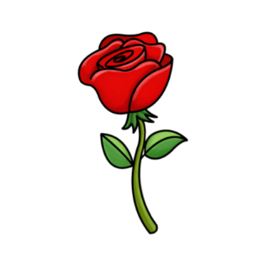Independent: __________________________________________________
   2. Dependent: __________________________________________________
   3. Controlled: __________________________________________________

__________________________________________________

1. To find out if watering plants with salty water affects how fast they grow.
   1. Independent: __________________________________________________
   2. 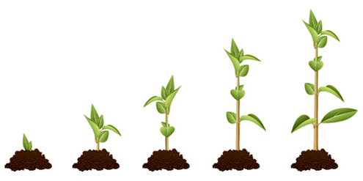Dependent: __________________________________________________
   3. Controlled: __________________________________________________

__________________________________________________

1. To find out if the amount of water given to plants affects how fast they grow.
   1. Independent: __________________________________________________
   2. Dependent: __________________________________________________
   3. Controlled: __________________________________________________

__________________________________________________

1. To find out if the amount of food given to fish affects their weight.
   1. Independent: __________________________________________________
   2. Dependent: __________________________________________________
   3. 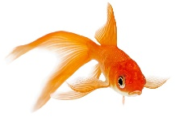Controlled: __________________________________________________

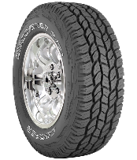__________________________________________________

1. To find out if different tyre treads affect the braking distance of a car.
   1. Independent: __________________________________________________
   2. Dependent: __________________________________________________
   3. Controlled: __________________________________________________

__________________________________________________

1. To find out if the temperature of water in a lake depends on the depth of the lake.
   1. Independent: __________________________________________________
   2. Dependent: __________________________________________________
   3. 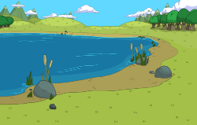Controlled: __________________________________________________

__________________________________________________

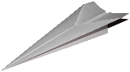

1. To find out if the mass of a paper plane affects how far it flies.
   1. Independent: __________________________________________________
   2. Dependent: __________________________________________________
   3. Controlled: __________________________________________________

__________________________________________________

1. To find out if dropping a ball from a greater height causes it to bounce higher.
   1. Independent: __________________________________________________
   2. Dependent: __________________________________________________
   3. Controlled: __________________________________________________

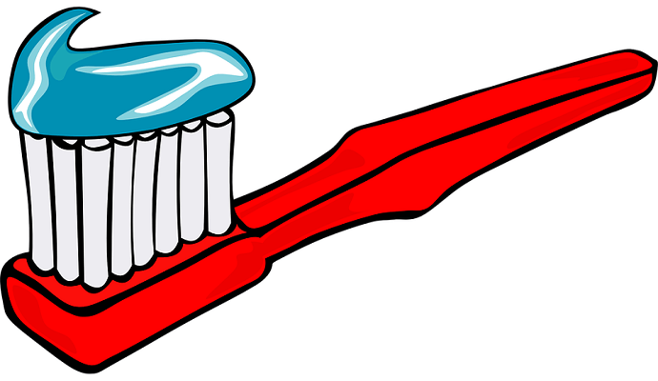__________________________________________________

1. To find out if more frequent teeth brushing reduces the number of fillings needed.
   1. Independent: __________________________________________________
   2. Dependent: __________________________________________________
   3. Controlled: __________________________________________________

_________________________________________________

1. To find out if the colour of a surface affects how fast it will heat up.
   1. Independent: __________________________________________________
   2. Dependent: __________________________________________________
   3. Controlled: __________________________________________________

__________________________________________________